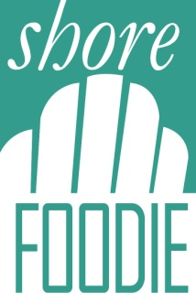
SHORE FOODIE ADVERTISNG CONTRACT
Restaurant Name____________________________________________________
Contact Name___________________________Contact Email_________________
Cell______________________
OPTIONS: (Please check appropriate box (s)
___$175 automatic payment on the first of the month for 6 months (September 1st Start)
___$945 upfront for 6 months (10% discount) by check or credit card
Pay By Debit or Credit Card:
Name on Card:_________________________________________________
Billing Address:_________________________________________________
Card Number___________________________________________________ Exp. Date___________
CCV: (3 digit security number on back of card) ___________________
I hereby consent to Shore Foodie charging me for my agreed upon subscription on the first of each month. I understand that the subscription cannot be cancelled prior to its expiration. Subscriptions will automatically renew unless we hear from you two weeks prior to expiration. Should a credit card/debit card be denied the subscriber agrees to pay subscription fee within 5 days of notice or the subscriber will be taken down from the site until restitution has been made. In any case the subscriber will be libel for the remainder of the subscription period.
___________________________________________ ___________
Authorized Signature of Owner or Manager Date
Kindly forward to:
Shore Foodie
Box 352
Brielle, NJ 08730
Jim Flynn|President|732.859.5643|shorefoodie@gmail.com

